Electronics Project Report
Name: Dhruv Hukkeri
Registration number: 20201065
Introduction:
For our project, group 20, we prepared a game of whack-a-mole. Whack-a-mole is a typical arcade game. A typical Whac-A-Mole machine consists of a waist-level cabinet with a play area and display screen, and a large, soft, black mallet. Five holes in the play area top are filled with small, plastic, cartoonish moles, which pop up at random. To score points you hit the plastic moles that pop up at random. In our version of whac-a-mole, we replaced the plastic moles with paper cups and the pop up of the moles was indicated by the lighting of a LED attached in front of the cups.
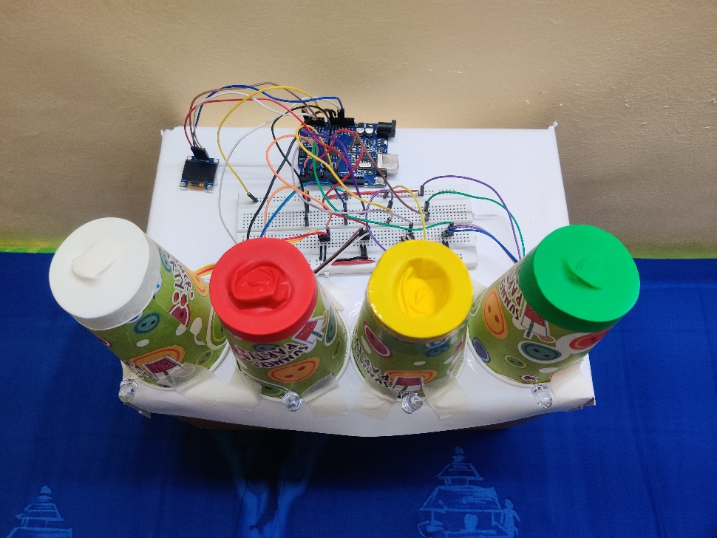

The basic working would be as follows: We cut out the top of the cups and attached rubber balloons on them. We attached shock sensors on those balloons using a double-sided tape. So, when you hit the cups the respective shock sensor detects the shock and gives input to the Arduino UNO. Now if the shock is within the time the LED is on, Arduino registers a hit and gives a point or else it registers a miss. An OLED screen displays the hit or miss as well as your score. The most crucial thing about the game would be the shock sensors since they detect the shock necessary for determining a miss or a hit.

Shock Switch Module:
A shock sensor has three pins; a negative, a positive and a signal. The negative pin is grounded whereas the positive is connected to a higher voltage, in our case +5V. The signal pin is connected to one of the digital pins on the Arduino since the sensor gives a digital signal.
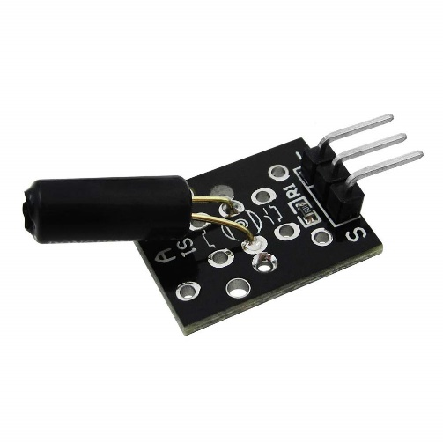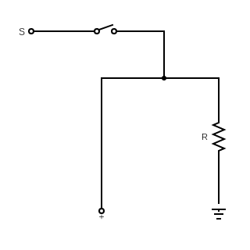

Using the above circuit diagram one can visualise how a shock switch module works. The grounded wire is the negative pin whereas the wire with positive potential is the positive pin. The third wire is the signal pin. The switch usually stays open until during a shock. Once the switch is closed during a shock, the signal pin is at high potential thus giving a positive signal to the Arduino.

The Circuit Diagram:
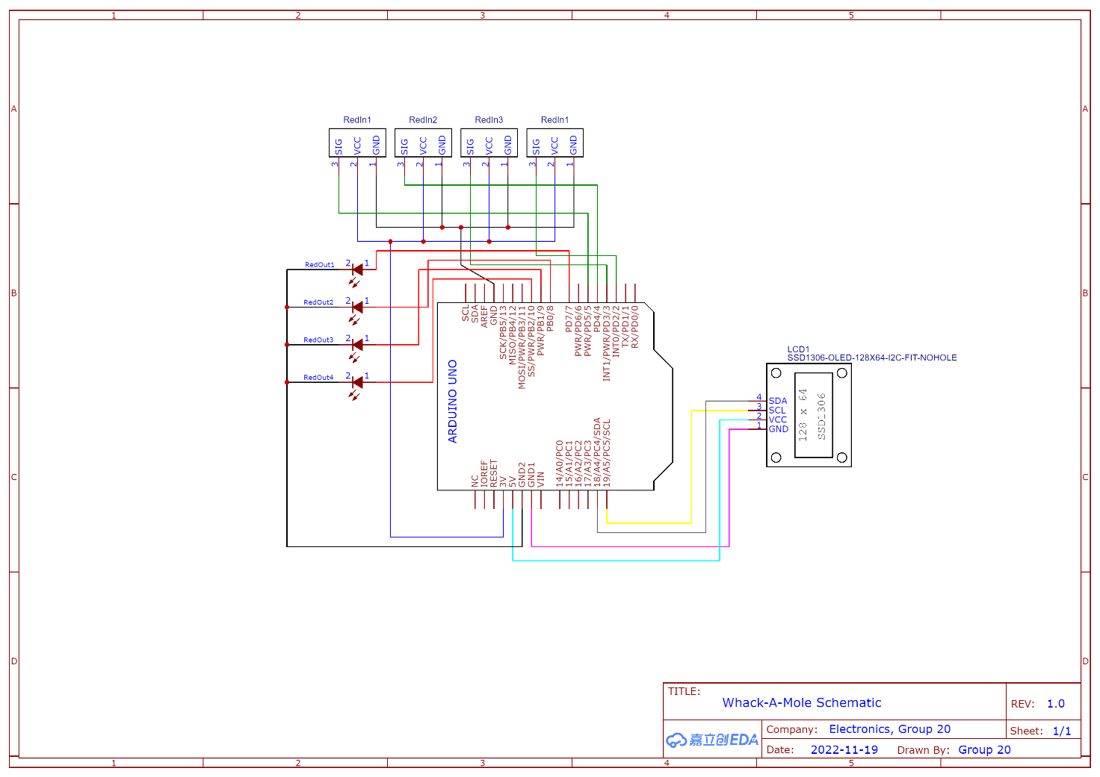
Execution:
The code randomly generates a number to turn on one of the LEDs for 0.5 seconds. If shock sensor to the corresponding LED that is on, detects a shock, the code adds a point to ‘hits’ and displays hit on the screen. Or else, the code displays a miss on the screen. The pause in-between two LEDs turning on is randomly generated as well. We have added different modes in the code as well. The modes being noob, intermediate, pro and God. Thus, the game becomes progressively difficult as game progresses and as you score more. The pause time decreases by 250ms as you go from noob to intermediate and further 150ms as you go to pro. God mode is the most difficult with the pause time being 50ms less than pro. The game ends after one minute of play. There are various changes you can make to the code. The biggest example is that the time for which the LED turns on can be randomly generated as well instead of being a constant. You can also make the misses to count as negative points to make the game even more difficult.
Code:
int red1 = 0;
int red2 = 0;
int red3 = 0;
int red4 = 0;
int red1In = 2; //In corresponds to input, that is the shock sensors
int red1Out = 7; // Out correspond to output, that is the LEDs
int red2In = 3;
int red2Out = 8;
int red3In = 4;
int red3Out = 9;
int red4In = 5;
int red4Out = 10;
int mole = -1;
int hits = 0;

int noob = 500; //different modes of play
int intermediate = 250;
int pro = 100;
int god = 50;
int mode = 0;

#include <Wire.h>
#include <Adafruit_GFX.h>
#include <Adafruit_SSD1306.h>

#define SCREEN_WIDTH 128 // OLED display width, in pixels
#define SCREEN_HEIGHT 64 // OLED display height, in pixels

Adafruit_SSD1306 display(SCREEN_WIDTH, SCREEN_HEIGHT, &Wire, -1);

void setup()
{
// display config
Serial.begin(115200);

if(!display.begin(SSD1306_SWITCHCAPVCC, 0x3C)) { // Address 0x3D for 128x64
Serial.println(F("SSD1306 allocation failed"));
while (true);
}
delay(2000);
display.clearDisplay();
display.display();

// pin config
pinMode(red1Out, OUTPUT);
pinMode(red2Out, OUTPUT);
pinMode(red3Out, OUTPUT);
pinMode(red4Out, OUTPUT);
pinMode(red1In, INPUT);
pinMode(red2In, INPUT);
pinMode(red3In, INPUT);
pinMode(red4In, INPUT);
}

void pause(int mode) {
unsigned long current;
unsigned long end;

mole = -1;
digitalWrite(red1Out, LOW);
digitalWrite(red2Out, LOW);
digitalWrite(red3Out, LOW);
digitalWrite(red4Out, LOW);

int pause = rand() % 500 + mode; //pause between LEDs is random and smaller for harder modes
current = millis();
end = millis() + pause;
while (millis()<end) {
red1 = digitalRead(red1In);
red2 = digitalRead(red2In);
red3 = digitalRead(red3In);
red4 = digitalRead(red4In);
if (red1 == LOW || red2 == LOW || red3 == LOW || red4 == LOW)
{
display.println("MISS!!");
display.display();
display.clearDisplay();
display.display();
delay(300);
}
}
}

// Randomly decide which LED to turn on
void displayMole() {
mole = rand() % 4 + 1;
if (mole==1) {
digitalWrite(red1Out, HIGH);
} else if (mole==2) {
digitalWrite(red2Out, HIGH);
}else if (mole==3) {
digitalWrite(red3Out, HIGH);
}else if (mole==4) {
digitalWrite(red4Out, HIGH);
}
}

void whackMole() {

unsigned long current;
unsigned long end;
current = millis();
end = millis() + 500; //LED lights up for 500ms
while (millis()<end) {
red1 = digitalRead(red1In); // read input value
if (red1 == LOW) { // check if the input is pressed
if (mole==1) {
display.println("HIT!!");
hits = hits + 1;
display.println(hits);
display.display();
delay(300);
display.clearDisplay();
display.display();
} else {
display.println("MISS!!");
display.display();
delay(300);
display.clearDisplay();
display.display();
}
}
red2 = digitalRead(red2In); // read input value
if (red2 == LOW) { // check if the input is pressed
if (mole==2) {
display.println("HIT!!");
hits = hits + 1;
display.println(hits);
display.display();
delay(300);
display.clearDisplay();
display.display();
} else {
display.println("MISS!!");
display.display();
delay(300);
display.clearDisplay();
display.display();
}
}
red3 = digitalRead(red3In); // read input value
if (red3 == LOW) { // check if the input is pressed
if (mole==3) {
display.println("HIT!!");
hits = hits + 1; //recording a hit
display.println(hits);
display.display();
delay(300);
display.clearDisplay();
display.display();
} else
display.println("MISS!!");
display.display();
delay(300);
display.clearDisplay();
display.display();
}
}
red4 = digitalRead(red4In); // read input value
if (red4 == LOW) { // check if the input is pressed
if (mole==4) {
display.println("HIT!!"); //recording a hit
hits = hits + 1;
display.println(hits);
display.display();
delay(300);
display.clearDisplay();
display.display();
} else {
display.println("MISS!!");
display.display();
delay(300);
display.clearDisplay();
display.display();
}
}
}
}

void loop() {
unsigned long current;
unsigned long end;
current = millis();
end = millis()+60000; //game ends after one minute

while(millis()<end) //modes changing based on your score
{
if (hits <= 5)
{
mode = noob;
}
else if (hits > 5 && hits <= 12)
{
mode = intermediate;
}
else if (hits > 12 && hits <= 20)
{
mode = pro;
}
else
{
mode = god;
}

display.clearDisplay(); // code for the LED
display.display();
display.setTextSize(2);
display.setTextColor(WHITE);
display.setCursor(30, 30);
pause(mode);

display.clearDisplay();
display.display();
display.setTextSize(2);
display.setTextColor(WHITE);
display.setCursor(30, 30);
displayMole();

display.clearDisplay();
display.display();
display.setTextSize(2);
display.setTextColor(WHITE);
display.setCursor(30, 30);
whackMole();
}

display.setCursor(30, 30);
display.print("Score:");
display.print(hits);
display.display();
exit(0);
}

Acknowledgements
I thank Giridharan and Basak for their invaluable contribution to this
project. I also thank Prof. Shouvik Datta for facilitating us to learn about
Arduino via this project.

